Setup Ubuntu Server Shared Folder (on Virtual Box)

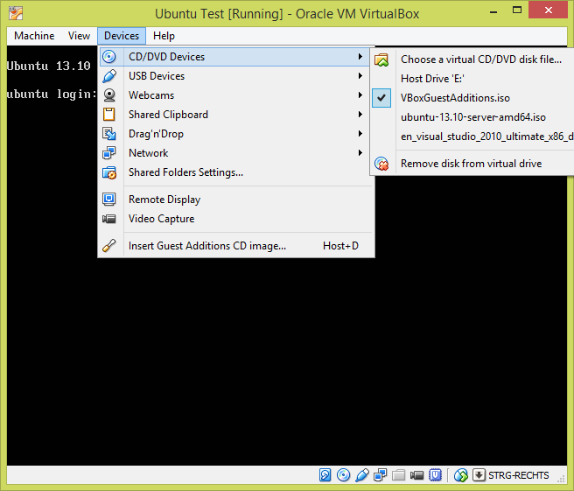

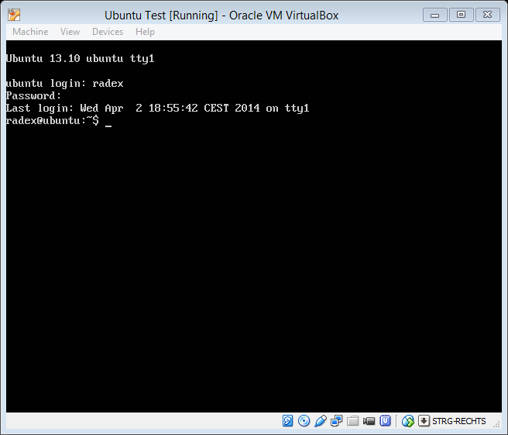

* sudo mount /dev/cdrom /media/cdrom
* sudo apt-get install build-essential

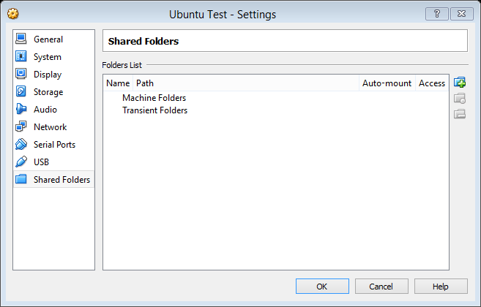

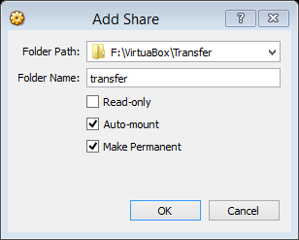

* cd /media/cdrom
* sudo ./VBoxLinuxAdditions.run install
* sudo usermod –a –G vboxsf radex
* sudo reboot